**COMP0005 Algorithms Coursework 1 (Group 5)**

**Methodology.**

We collected the average time taken for each algorithm to execute five times. To test linearithmic complexity, which is not supported in Microsoft Excel, we plotted time against and plotted a linear trendline. A graph and the best fit trendline, determined by the trendline with the highest Correlation of Determination, is chosen to be the most reliable time complexity.

**Jarvis March Algorithm – Analysis.**

**Random Input** *– Theoretical Computational Complexity* – For random input the complexity would be linear . This is because for every point on the hull we iterate through all the other points to decide which is next. Time complexity is therefore () where is number of points we input, and is the number of points on the hull, since in the average case is significantly smaller than when is large we can drop the hence we are left with a linear complexity.

**Worst-case Scenario** *–* *Theoretical Computational Complexity* – For the worst case, the complexity would be quadratic because the worst case occurs when all the points lie on the convex hull. With the same reason as the random data generation ().

**Random Input** *– Experimental Computational Complexity* – The analysis shows the complexity is linear , as predicted from the theoretical analysis.

**Worst-case Scenario** *– Experimental Computational Complexity* – The analysis shows the complexity is quadratic as predicted from the theoretical analysis.

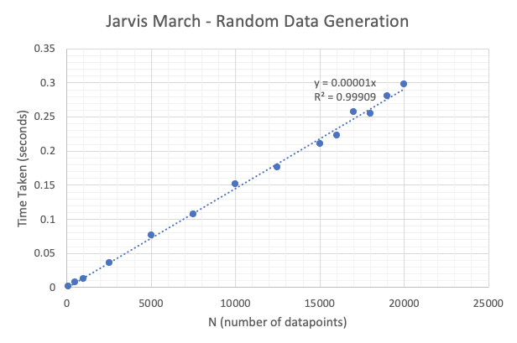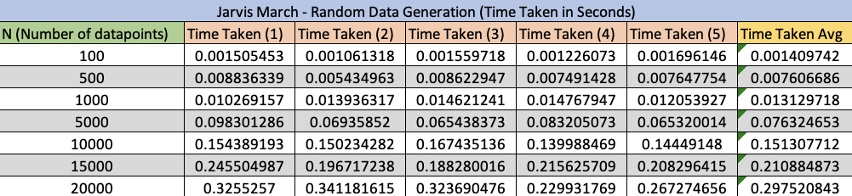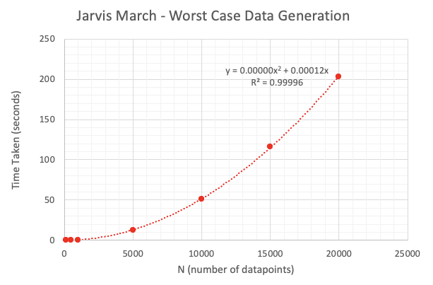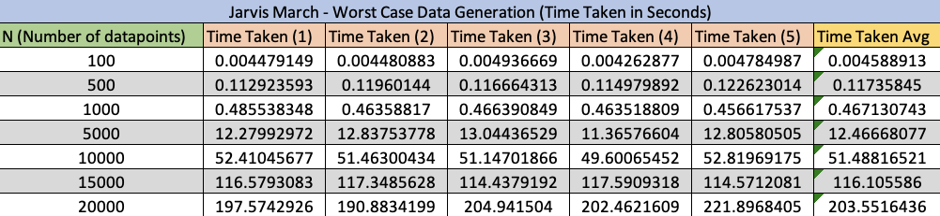

**Graham Scan Algorithm – Analysis.**

**Random Input** *– Theoretical Computational Complexity* – For random input the complexity would be . We split the analysis of the algorithm into different parts. The order of the functions that is used in the graham scan algorithm is explained in the program’s source code.

1. There are 5 parts of the program with time complexity reason that it iterates through the list once, i.e. calculating point P, converting cartesian to polar, removing the polar form points with no magnitude, removing the polar coordinates with the same angle but smaller magnitude and converting points back into cartesian.
2. The sorting algorithm that sorts the angle has complexity on average and worst case since we used merge sort.
3. The calculation of the convex hull at most iterates through the list twice (Graham, 1972), hence time complexity
4. Taking the sum, + + =

**Random Input** *– Experimental Computational Complexity* – The analysis shows the complexity is linearithmic as predicted from the theoretical analysis.

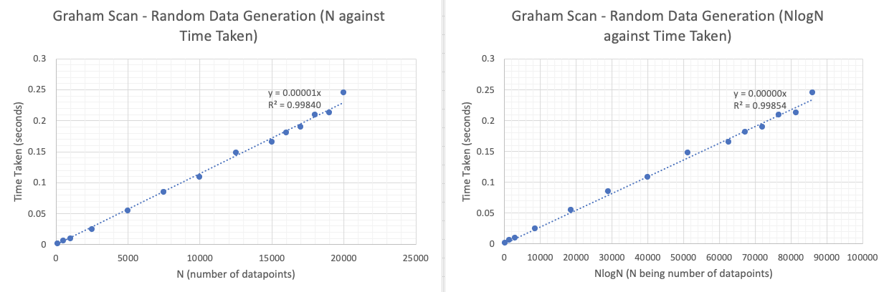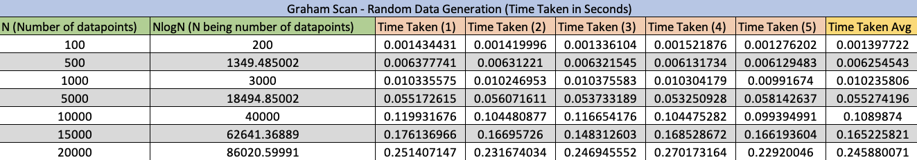

**Worst-case Scenario** *– Theoretical Computational Complexity* – For the worst case, the complexity would be  with the similar reasoning as random case, as merge sort contributes most to the time complexity. We have attempted to make datasets that would cause the sorting algorithm to do maximum amount of work, which happens when merge sort does the greatest number of comparisons. This is done by alternating elements within a sorted array such that at every merge stage, all elements from both auxiliary arrays are compared, rather than having one auxiliary array being concatenated with the returning merged array.

**Worst-case Scenario** *– Experimental Computational Complexity* – The analysis shows the complexity is linearithmic as predicted from the theoretical analysis.

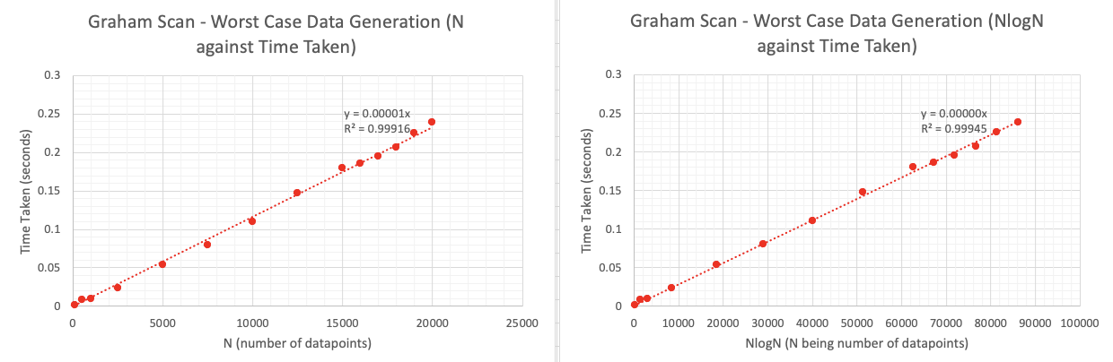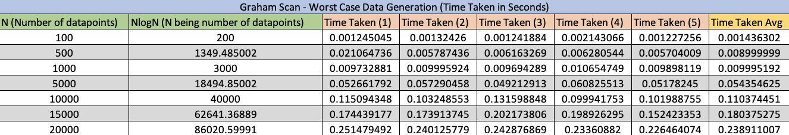

**Extended Graham Scan Algorithm – Analysis.**

**Random Input** – *Theoretical Computational Complexity* – Same complexity as Graham scan with the same reasoning as the heuristics has linear complexity.

**Random Input** *– Experimental Computational Complexity* – The analysis shows the complexity is linearithmic as predicted from the theoretical analysis.

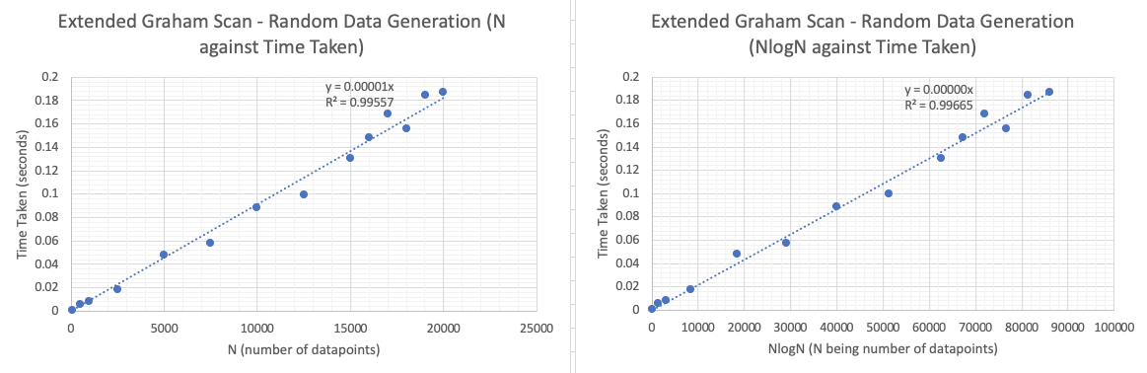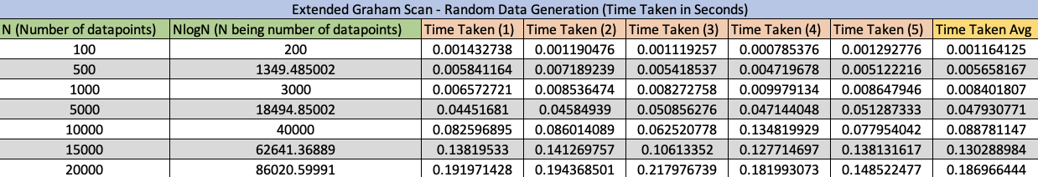

**Worst-case Scenario** *– Theoretical Computational Complexity* – Same complexity as Graham scan with the same reasoning as the heuristics has linear complexity.

**Worst-case Scenario** *– Experimental Computational Complexity* – The analysis shows the complexity is linearithmic as predicted from the theoretical analysis.

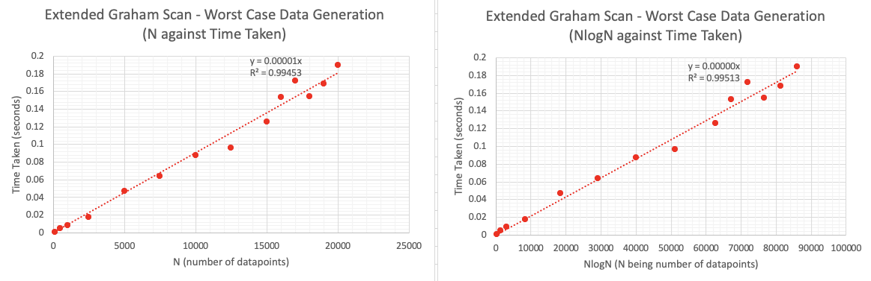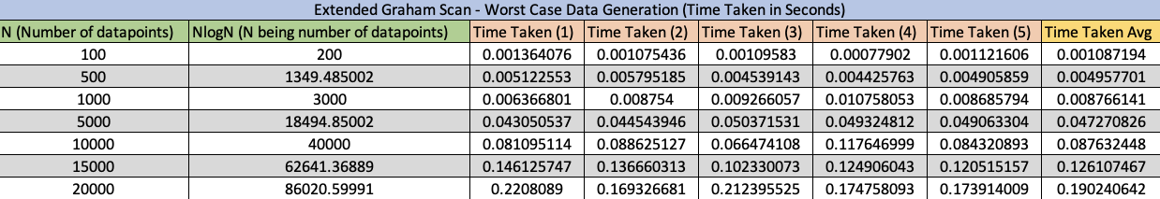

**Extended Graham Scan Heuristics Explained.**

The extended graham scan algorithm improves upon the original graham scan by adding a point removal algorithm. This is based on the observation that points that are enclosed within the shape formed by the points with ), (, and would not be in the set of the convex hull. By discarding these points, the graham scan goes through much less data points during the tracing phase especially significant for large datasets, hence speeding up execution time.

The algorithm is as follows:

* Compute , , , as the boundary points and the area of the shape  that the points formed.
* For each point within the input set, compute the sum of the area of triangles that the form with the boundary points.
* If the sum does not equal to the area of quadrilateral , then is discarded.

As a result of this extension, the execution time of the algorithm is  times faster for random datasets as shown by Figure 1.

**Concluding Comparison.**

For random case scenario Jarvis March has a linear complexity. Although Graham Scan has linearithmic complexity, it is faster for our experimental random datasets as shown by the Figure 2. For worst case scenario Jarvis march has a quadratic complexity while graham has linearithmic complexity. As a result of the comparisons above, Graham Scan has proven to be the more efficient algorithm when looking at random and worst-case datasets. Overall, Graham scan is more reliable and efficient.

**References.**

* Alshamrani, R., Alshehri, F. and Kurdi, H., 2020. A Preprocessing Technique for Fast Convex Hull Computation. Procedia Computer Science, 170, pp.317-324.
* Graham, R., 1972. An efficient algorith for determining the convex hull of a finite planar set. Information Processing Letters, 1(4), pp.132-133.
* https://stackoverflow.com/questions/24594112/when-will-the-worst-case-of-merge-sort-occur

**Additional Figures.**

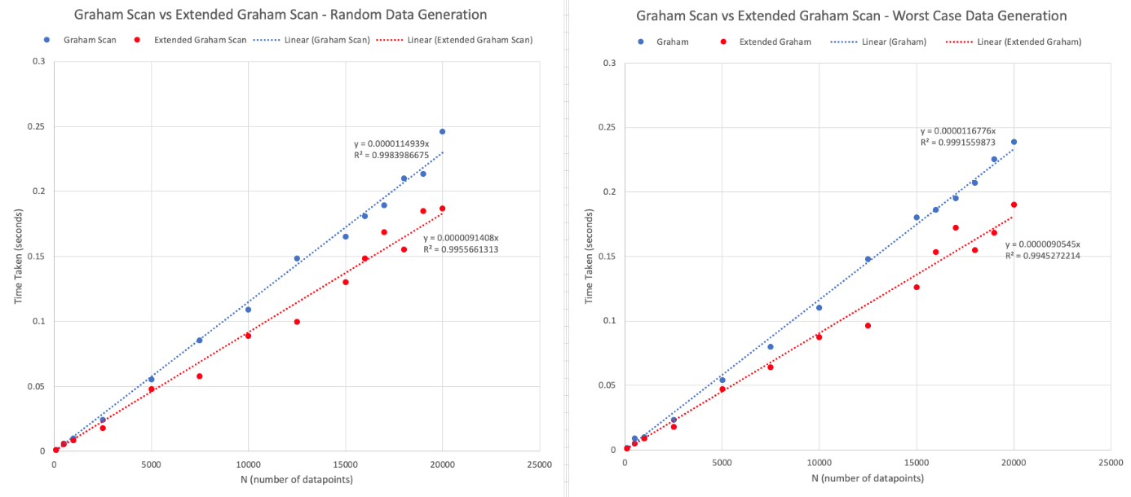

Figure 1: Graham Scan vs Extended Graham Scan

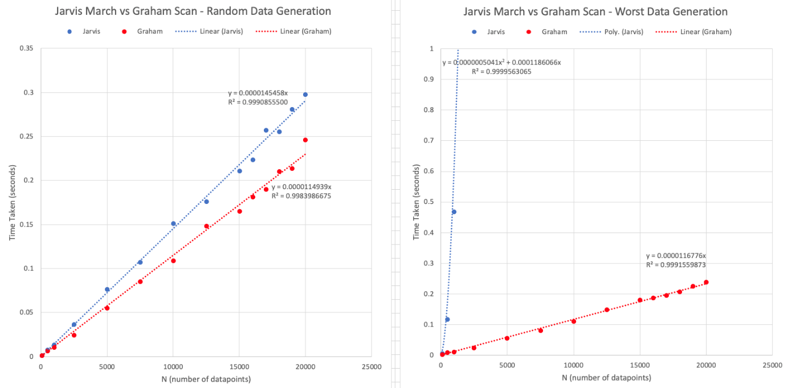

Figure 1: Jarvis March vs Graham Scan